USER GUIDE

Delete users

September 2018

Version 1.01

Pharmacon ITC303/309 Group

Document Revisions

|  |  |  |
| --- | --- | --- |
| Date | Version Number | Document Changes |
| 14/09/2018 | 1.01 | Initial |
|  |  |  |
|  |  |  |
|  |  |  |
|  |  |  |
|  |  |  |
|  |  |  |
|  |  |  |
|  |  |  |

Table of Contents

1 Introduction 4

1.1 Scope and Purpose 4

1.2 Process Overview 4

2 Delete users 6

2.1 Locate User (login) 6

2.1.1 Load Delete users Form: 6

2.1.2 Delete users Form: 7

# Introduction

## Scope and Purpose

The purpose of this user guide is to provide instructions on how to change the password for a user (login). No other features of the Pharmacy Error Tracker (PET) application will be discussed in this user guide.

* To be able to use PET, the user will need basic knowledge of logging into an online application and using a search function to locate records.
* This feature is only available to a user with administrator rights.

## Process Overview

The administrator will need to log into PET using their valid username and password.

* The Welcome Page will be presented on successful login.
* The administrator will need to select Delete users via the menu bar or the button on the menu page.

The administrator will need to know the user’s login or part thereof for search purposes.

Login screen when PET is launched

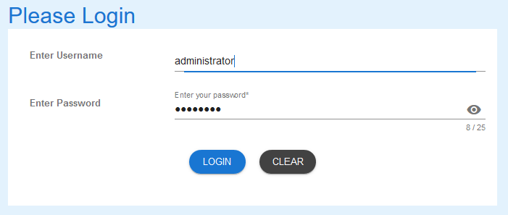

Welcome Page on successful login

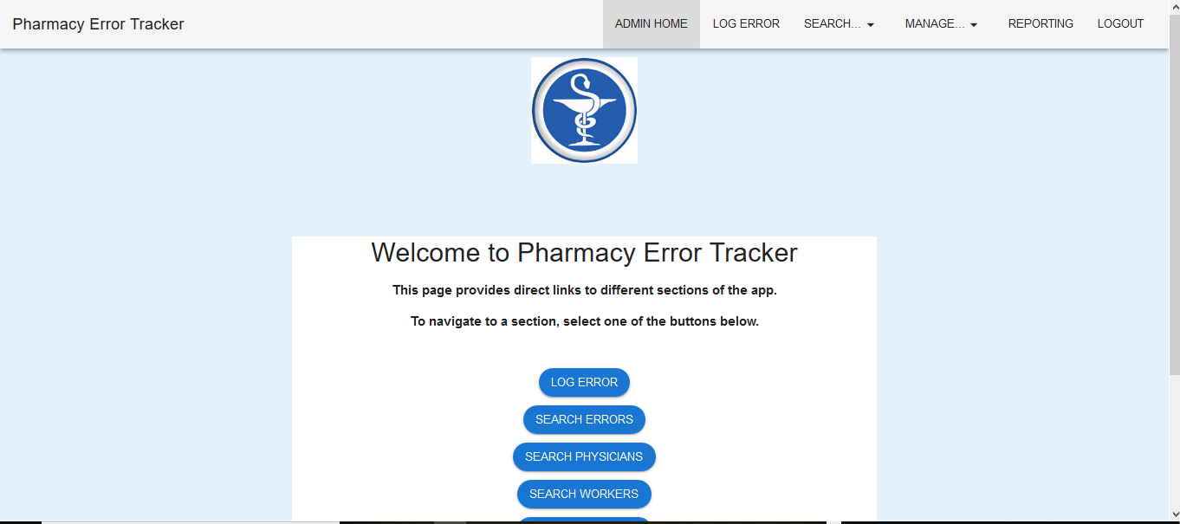

# Delete users

To search for a user, the administrator will need to launch the application, login with a valid user name and password with administration rights. Using the search function, the administrator will be able locate a user (login) relating to the search criteria entered and be able to change the password.

## Locate User (login)

Administrator must have located the required user via the Search Users function.

*NOTE: The administrator cannot delete themselves as the delete button is not available.*

### Search for User (Login):

1. Use the search bar to locate the user that is to be deleted. Select “Delete users” button.

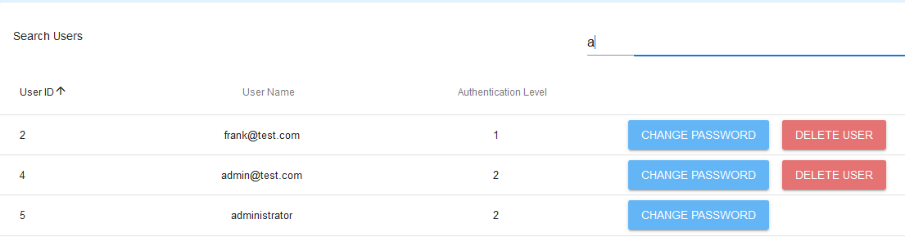

### Delete User:

Once the user to be deleted has been located, the delete user button is to be selected.

1. Select Delete User. Warning popup box will appear

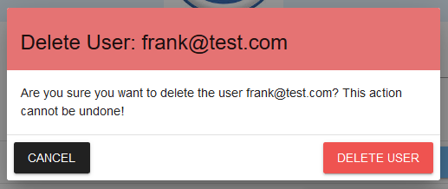

1. Check that the user (login) in the warning corresponds with user (login) to be deleted.
2. If the record selected is incorrect, select “Cancel”. The previous search screen will appear. Either start a new search or select correct record.

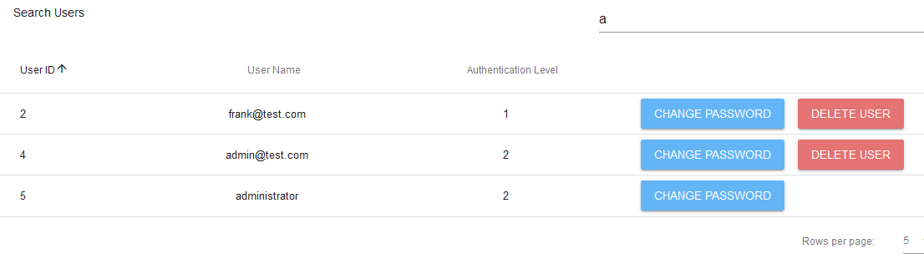

1. Once correct record has been selected, click “Delete User”

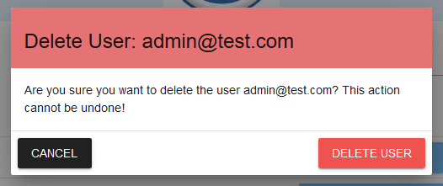

1. A message appears to indicate that the user (login) has been deleted and the previous search appears. The delete record will not appear in the results.

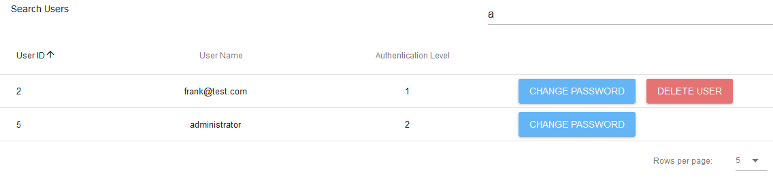

If you encounter issues not addressed by this user guide, please contact your account manager for additional support.